NAME:G.DHANUSHA SREE
REG NO:192325012

- Write a C program for Caesar cipher involves replacing each letter of the alphabet with the letter standing k places further down the alphabet, for k in the range 1 through 25.

Program:

text = input("Enter plaintext: ")
k = int(input("Enter key (1-25): "))

if k < 1 or k > 25:
print("Enter key between 1 and 25")
else:
result = ""

for ch in text:
if ch.isupper():
result += chr((ord(ch) - 65 + k) % 26 + 65)
elif ch.islower():
result += chr((ord(ch) - 97 + k) % 26 + 97)
else:
result += ch

print("Encrypted text:", result)
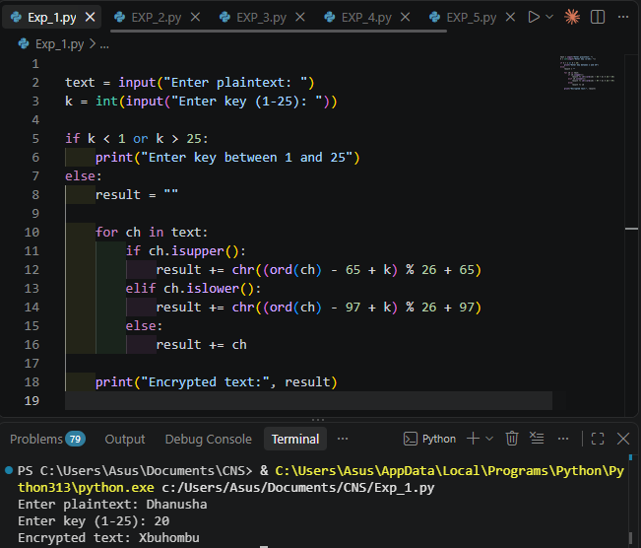

- Write a C program for monoalphabetic substitution cipher maps a plaintext alphabet to a ciphertext alphabet, so that each letter of the plaintext alphabet maps to a single unique letter of the ciphertext alphabet.

Program:

text = input("Enter plaintext: ")
key = input("Enter 26-letter key: ").upper()

if len(key) != 26 or set(key) != set("ABCDEFGHIJKLMNOPQRSTUVWXYZ"):
print("Invalid key. Enter all 26 letters exactly once.")
else:
result = ""

for ch in text:
if ch.isupper():
result += key[ord(ch) - ord('A')]
elif ch.islower():
result += key[ord(ch) - ord('a')].lower()
else:
result += ch

print("Encrypted text:", result)

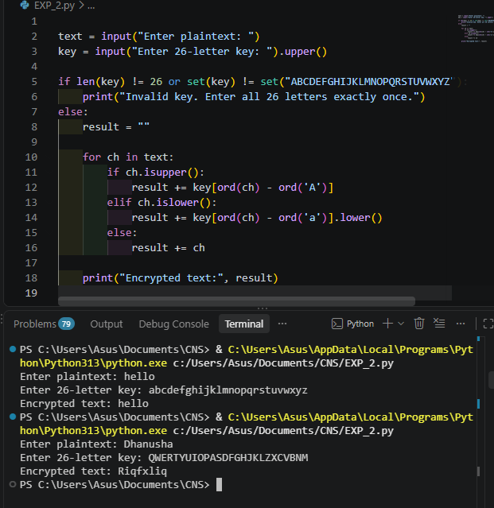

- Write a C program for Playfair algorithm is based on the use of a 5 X 5 matrix of letters constructed using a keyword. Plaintext is encrypted two letters at a time using this matrix.

Program:

def make_matrix(key):
alphabet = "ABCDEFGHIKLMNOPQRSTUVWXYZ"
chars = ""

for ch in (key.upper() + alphabet):
if ch == "J":
ch = "I"
if ch in alphabet and ch not in chars:
chars += ch

return [list(chars[i:i+5]) for i in range(0, 25, 5)]

def encrypt(text, matrix):
text = "".join(c for c in text.upper() if c.isalpha())
text = text.replace("J", "I")

pairs = []
i = 0

while i < len(text):
a = text[i]

if i + 1 == len(text):
b = "X"
i += 1
elif text[i] == text[i + 1]:
b = "X"
i += 1
else:
b = text[i + 1]
i += 2

pairs.append(a + b)

result = ""

for pair in pairs:
a, b = pair
r1 = c1 = r2 = c2 = 0

for r in range(5):
for c in range(5):
if matrix[r][c] == a:
r1, c1 = r, c
if matrix[r][c] == b:
r2, c2 = r, c

if r1 == r2:
result += matrix[r1][(c1 + 1) % 5]
result += matrix[r2][(c2 + 1) % 5]
elif c1 == c2:
result += matrix[(r1 + 1) % 5][c1]
result += matrix[(r2 + 1) % 5][c2]
else:
result += matrix[r1][c2]
result += matrix[r2][c1]

return result

key = input("Enter keyword: ")
text = input("Enter plaintext: ")

matrix = make_matrix(key)

print("Playfair Matrix:")
for row in matrix:
print(" ".join(row))

print("Encrypted text:", encrypt(text, matrix))
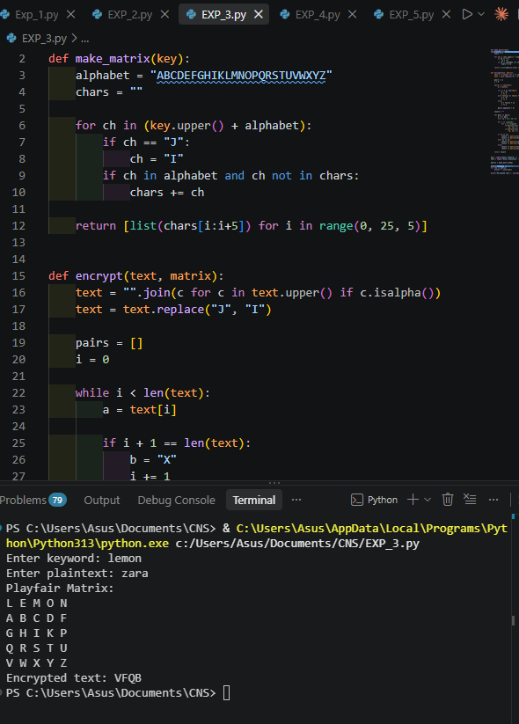

- Write a C program for polyalphabetic substitution cipher uses a separate monoalphabetic substitution cipher for each successive letter of plaintext, depending on a key.

Program:

text = input("Enter plaintext: ").upper()
key = input("Enter keyword: ").upper()

if not key.isalpha():
print("Enter a valid alphabetic key.")
else:
result = ""
j = 0

for ch in text:
if ch.isalpha():
shift = ord(key[j % len(key)]) - 65
result += chr((ord(ch) - 65 + shift) % 26 + 65)
j += 1
else:
result += ch

print("Encrypted text:", result)

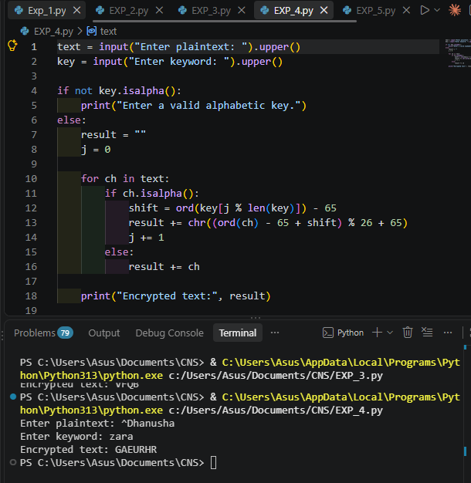
- Write a C program for generalization of the Caesar cipher, known as the affine Caesar cipher, has the following form: For each plaintext letter p, substitute the ciphertext letter C: C = E([a, b], p) = (ap + b) mod 26 A basic requirement of any encryption algorithm is that it be one-to-one. That is, if p q, then E(k, p) E(k, q). Otherwise, decryption is impossible, because more than one plaintext character maps into the same ciphertext character. The affine Caesar cipher is not one-to-one for all values of a. For example, for a = 2 and b = 3, then E([a, b], 0) = E([a, b], 13) = 3. a. Are there any limitations on the value of b? b. Determine which values of a are not allowed.

Program:

import math

print("Valid values of a:")
print([a for a in range(26) if math.gcd(a, 26) == 1])

print("b can be any integer, reduced modulo 26.")

a = int(input("Enter a: "))
b = int(input("Enter b: "))
text = input("Enter plaintext: ").upper()

if math.gcd(a, 26) != 1:
print("Invalid a. Choose a relatively prime to 26.")
else:
result = ""

for ch in text:
if ch.isalpha():
p = ord(ch) - 65
c = (a * p + b) % 26
result += chr(c + 65)
else:
result += ch

print("Encrypted text:", result)

print("Answer (a): No special restriction on b.")
print("Answer (b): a must be relatively prime to 26.")
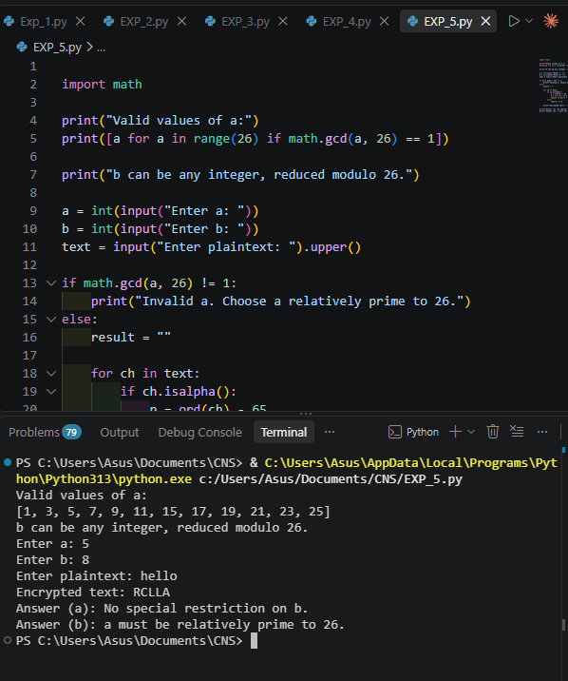

- Write a C program for ciphertext has been generated with an affine cipher. The most frequent letter of the ciphertext is “B,” and the second most frequent letter of the ciphertext is “U.”Break this code.

Program:

import string

# Assumption: E maps to B, and T maps to U
a = 3
b = 15

print("Assumed key:")
print("a =", a)
print("b =", b)

cipher = input("Enter ciphertext: ").upper()
result = ""

# Inverse of 3 modulo 26 is 9
for ch in cipher:
if ch in string.ascii_uppercase:
c = ord(ch) - 65
p = (9 * (c - b)) % 26
result += chr(p + 65)
else:
result += ch
print("Decrypted text:", result)
